Name:__________________________________ Date: ______________

What’s up with the weather?

Weather Station Model Lab

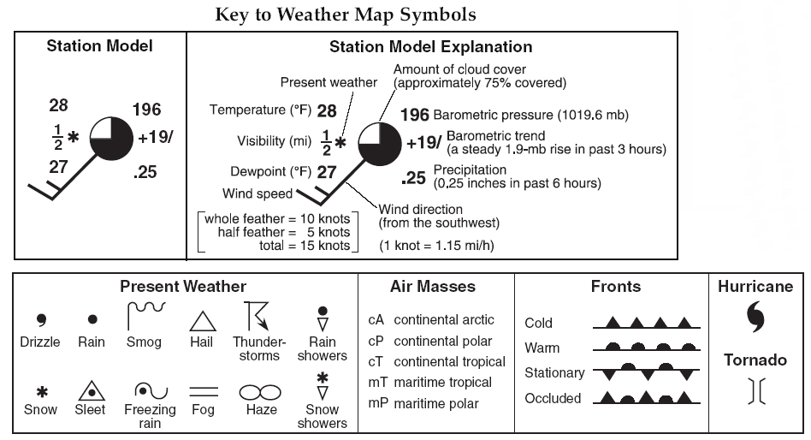**Introduction:** Much like the concept of genus and species names, a weather station model is a set of symbols that scientists and meteorologists have agreed upon to consistently chart weather variables on a weather map. These station models are specific to the observation station where they are gathered however, they can be understood by all meteorologists due to the consistency of symbols used. The station model was invented in 1941 and has remained almost identical since then; the following weather variables can be depicted and understood from a station model: temperature, dew point, wind, cloud cover, air pressure, pressure tendency, and precipitation. An example of a station model is below.

**THIS CHART CAN BE FOUND ON PAGE _______ OF YOUR EARTH SCIENCE REFERENCE TABLES**

**Procedure:**

1. Interpret station model and fill in corresponding weather variables
2. Create model from text and picture of weather
3. Make up a weather report and create a station model for it

Part 1: Interpret the model below and add units

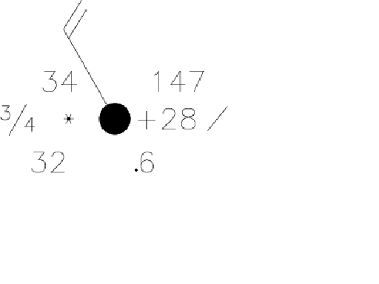

1. Temperature:_________________________
2. Present weather:____________________________________________
3. Dew point:______________________________
4. Wind speed
5. Wind direction:__________________________________________
6. Barometric pressure:______________________________
7. Cloud coverage:______________________________
8. Visibility: ______________________________________
9. Precipitation: ________________________________

Part 2: Create an accurate station model from the description below. Fill in the information from the text and then create the model.

Weather Report: Good morning New Paltz, looks like we will be breaking some temperature records today! Currently, the temperature is at 90°F with a steady wind from the East, easy, breezy wind at 10 knots. The dew point is 82°F. If you choose to leave the air conditioning of your home and brave the heat you will see a variety of cloud types; cirrostratus clouds up high in the sky, developing cumulus closest to the ground and thin altocumulus in between. Cloud coverage is presently at 50%. The barometric pressure is currently at 1014.2 millibars (**be sure to code this!)** with a pressure change of 1.6 millibars (**use the hint page)** which has been steadily rising over the last three hours. Presently there is a light drizzle decreasing the visibility to 2 miles.

1. Temperature:_________________________
2. Present weather:____________________________________________
3. Dew point:______________________________
4. Low cloud type:_____________________________________________
5. Pressure change:______________________________
6. Pressure tendency:______________________________
7. Wind speed and direction:__________________________________________
8. Barometric pressure:______________________________
9. Cloud coverage:______________________________
10. Visibility: _____________________________

STATION MODEL DRAWING:

Part 3: Create a unique weather report and draw its corresponding station model in the box below. Your report can be for any location in the world.

Requirements:

* symbols in the station model must reflect conditions stated in the report
* If there is precipitation there must be some cloud cover
* The dewpoint must be lower or equal to the air temperature
* You must incorporate all weather variables into your report and into your station model
* HAVE FUN, BE CREATIVE :)

WEATHER REPORT:

STATION MODEL DRAWING:

QUESTIONS:

1. Convert 8 knots to a miles per hour measurement for **wind speed:**
2. What is the highest dew point possible for an air temperature of 65°F?
3. Convert the following and show work:

* 72°F to Celsius
* 23°C to Fahrenheit
* 24 mph wind to knots

1. Wind is always described by the direction in which it originates (where is comes FROM). How would you draw a wind tail for a wind direction:

Northeast South Southeast

What is the cloud cover? What is the cloud cover? What is the cloud cover?

7.) If units are so important in science, why don’t meteorologists use them on a weather station model?