Name:___________________________________________ Date:____________ Class:_______
Lab Partner: _______________________________________
LAB ____: SHAKE, RATTLE AND ROLL
Introduction: Count from one to thirty and an earthquake has just occurred somewhere in the world. Earthquakes occur when there is movement along a fault and are measured in terms of magnitude. The magnitude is charted on the Richter Scale; an exponential scale that ranges from 0.1-10. The greatest earthquake ever recorded was a 9.5 in the Valdivia earthquake in Chile in 1960. Not every earthquake is felt. Some are so small that they would go unnoticed without modern instruments called seismographs.
Objective: Use http://earthquake.usgs.gov to research past earthquakes. You will graph magnitudes and find the relationship between location and earthquake intensity. In addition, you will also learn to interpret a seismogram, locate the epicenter of an earthquake and understand differences in seismic waves.
Vocabulary:
Fault: ________________________________________________________________________________________
______________________________________________________________________________________________
Epicenter: ______________________________________________________________________________________
______________________________________________________________________________________________
Focus: ________________________________________________________________________________________
______________________________________________________________________________________________
Focal depth: ____________________________________________________________________________________
_______________________________________________________________________________________________
P-wave: ________________________________________________________________________________________
_______________________________________________________________________________________________
S-wave: ________________________________________________________________________________________
_______________________________________________________________________________________________
Seismograph: ___________________________________________________________________________________
_______________________________________________________________________________________________
Seismogram: ____________________________________________________________________________________
_______________________________________________________________________________________________

Procedure A: Birthday Earthquakes, steps for internet navigation
- http://earthquake.usgs.gov/
- Click on the “Earthquakes” tab on the top left of the banner
- Click on the green magnifying glass on the top right of the page that says “Search Earthquake Archives”
- Click “Global Worldwide Search”
- Scroll down to “Optional Search Parameters”
- Enter your birthday for the starting and ending boxes : year, month (01=January), and day (01=first)
- Then click “submit search”
Data for Procedure A:
Record the date of all earthquakes (your birthday) Year, month, day:________-______-______
Record the total amount of earthquakes on your birthday: __________
Record the latitude-longitude & magnitude of 20 earthquakes from different locations. When you select a specific earthquake on the left tab, more information about it will be displayed on the bottom left of the screen.
Data Table A:
Latitude and longitude (just degrees) | Location | Magnitude

Using the longitude and longitude coordinates and page 5 of your ESRT’s, plot the locations of each earthquake with an X and the magnitude.

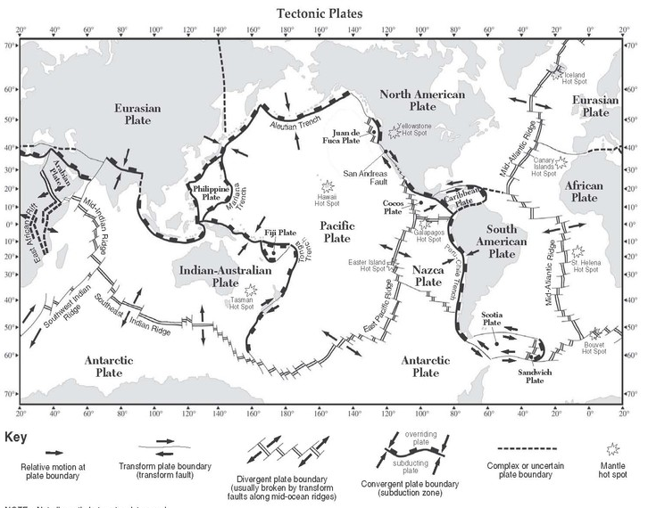
Make a Bar Graph that shows the magnitude comparison of all 20 earthquakes.
- Number the y-axis from 0-10.
- Title the y-axis magnitude
- Title the graph.
- Draw diagonal lines in the bars of the earthquakes that occurred on a plate boundary.
TITLE: ______________________________________________________________
Earthquakes

Discussion Questions:
- How many total earthquakes occurred on your birthday?

- Is that more or less than what you thought? Why?

- What was the largest magnitude earthquake on your birthday?

- How much bigger is your biggest earthquake compared to an earthquake with a magnitude of 1.0? Express in standard notation and scientific notation. (HINT: Magnitude 2 is 10 times stronger than a magnitude 1, magnitude 3 is 100 times stronger than a magnitude 1, etc). Example: 5.4 magnitude= 10000 times stronger

Standard notation:___________________________

Scientific notation:___________________________

- An earthquake with a magnitude of 6 or higher is considered to be severe. How many severe earthquakes occurred on the day you were born?

- Look at the earthquakes you plotted on the map on page 3. What patterns do you observe about the position of the earthquakes?
Procedure B: Locating an epicenter
“Good evening, this is News 4 New York, I am Charles Richter reporting live from Downtown. Most of the country was shaken up today as we experienced one of the biggest earthquakes in the United States on record. Seismologists in Chicago, Illinois, Tampa, Florida and Wink, Texas were able to get arrivals of P&S waves through their seismographs, but the quake was so powerful that seismologists lost all power and access to their labs and weren’t able to locate the epicenter. We need YOUR help. We must find the epicenter so we can predict future quakes and aftershocks; the fate of the country is in your hands!”
Follow the steps below:
- To locate the epicenter on the map, for each city draw a circle whose radius is equal to the distance from that city to the epicenter (Use the scale of distance of your map to set the drawing compass at the correct radius)
2. Mark and label the epicenter on the map where all three circles intersect with an “X”.

Think you’ve got it? You will need to use page 11 of your ESRT and the seismologists’ limited data from Table B. Good luck!

Table B
Location | P-wave arrival time | S-wave arrival time
Chicago, Illinois | 2:33:00 | 2:35:35
Tampa, Florida | 2:35:10 | 2:39:15
Wink, Texas | 2:32:10 | 2:34:00

Data Table B
SEISMOGRAPH STATION | Arrival (clock time) |  | Difference in arrival time (min. and sec.) | Distance to epicenter (km) | “P” Wave travel time (min. and sec.) | Time of origin (hr., min. and sec.) *p wave arrival- p wave travel
 | “P” Wave | “S” Wave
CHICAGO
TAMPA
WINK

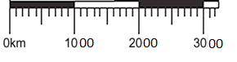

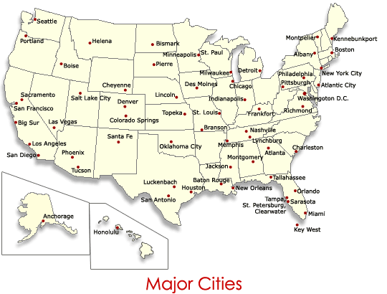

Wink
Discussion Questions:
- Where was the approximate epicenter of the major earthquake?

- What materials can “P” waves travel through?

- What materials can “S” waves travel through?

- What wave is faster? Why?

- Circle the correct choice: (S) (P) waves are the slower and more destructive type of seismic wave.

- Why do you have to have at least three stations to locate an epicenter?

Conclusion: Now that you are the expert on locating epicenters, write a step by step procedure on how someone can locate an epicenter.
Use the words: “P-waves” “S-waves” “3 locations” “radius” “ESRT chart” “difference in arrival times”

