Name: _________________________________________ Date: ____________________
Lab Partner: ____________________________________

LAB 9: PLANET JIGSAW

Purpose: By using clues, much like Alfred Wegner did, you will be able to put Earth’s continents back together to how they were 300 million years ago in the supercontinent “Pangaea.”

Experimental Question: How were the continents arranged in the last supercontinent, Pangaea?

Hypothesis: Draw how you think the continents looked:

Materials: scissors, glue stick, textbook

Procedure:
- Travel to each continent and look for clues that would suggest continents fitting with other continents (matching mountain chains and fossils).
- Record all observations directly on the appropriate continent of your “Pangaea Cut Out Sheet”
- When you think you have the supercontinent jigsaw figured out, cut your continents out and rearrange them so they reflect Pangaea 300 million years ago!

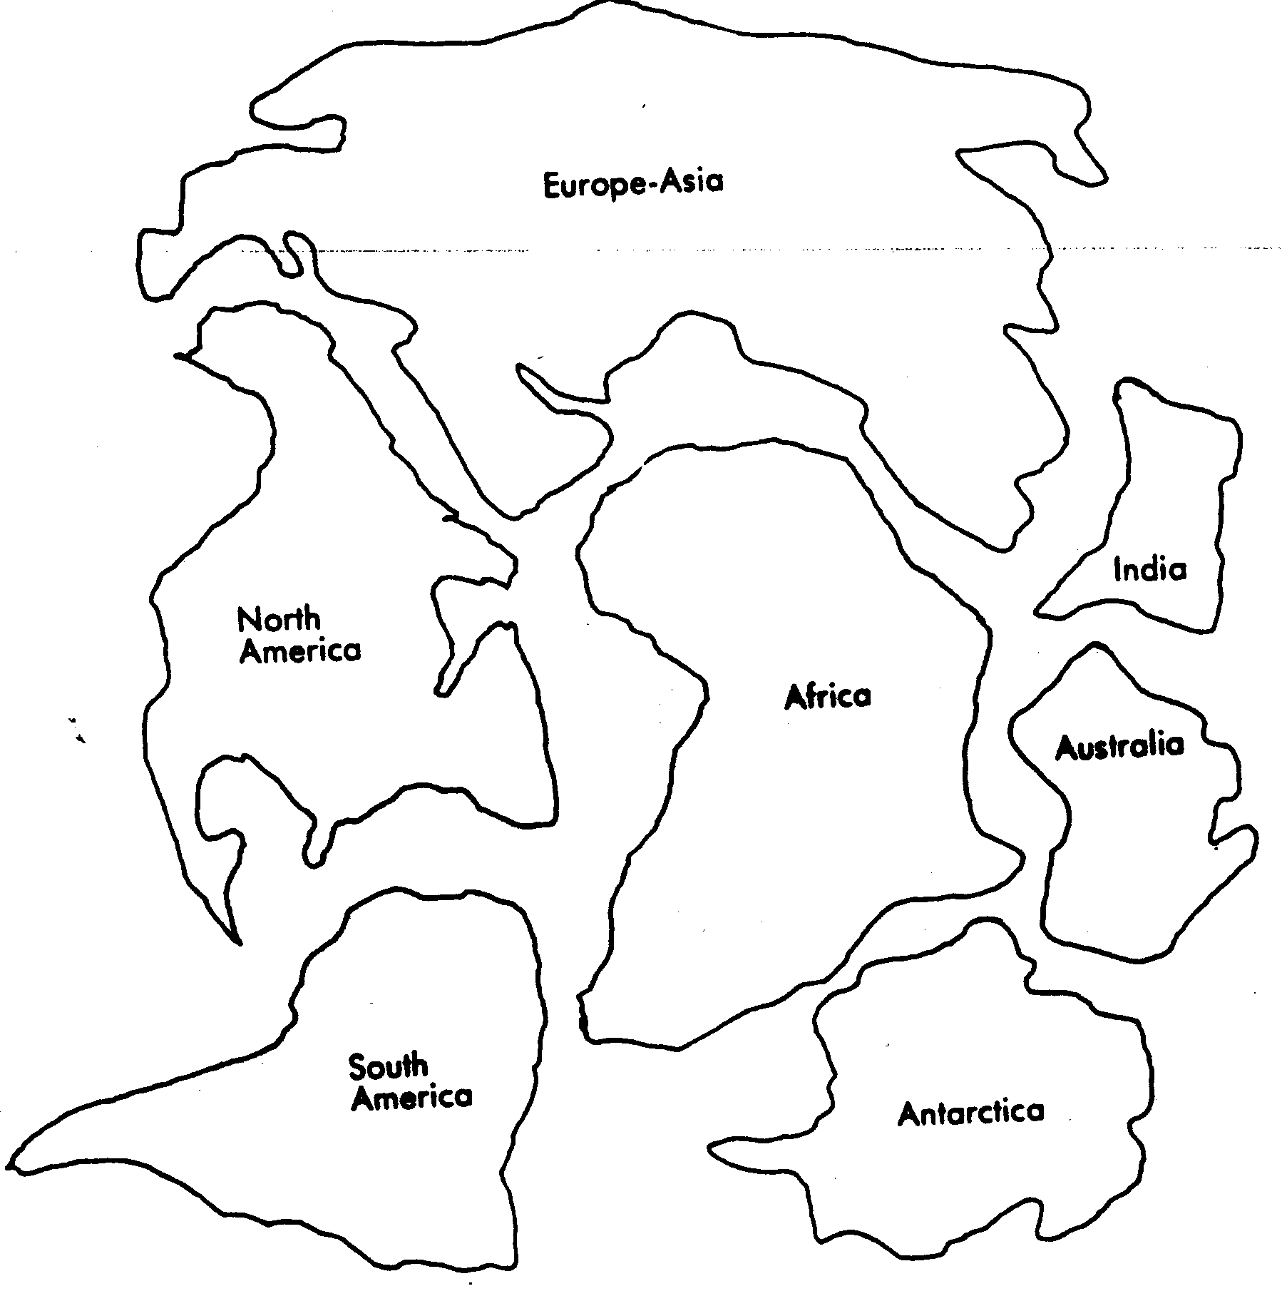
Data: Pangaea Cut Out Sheet
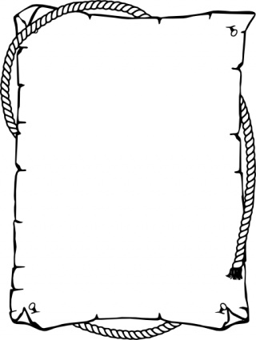
Analysis: Paste your Pangaea Supercontinent Below:

Conclusion: Read Pages 220 and 221 in order to answer the questions below. Answer all questions in complete sentences.

- Who was the first scientist to come up with the idea of continental drift?

- What was the main reason most scientists did not accept the idea of continental drift?

- Wegner offered several types of evidence to support his idea of continental drift. Write a short paragraph that summarizes his evidence.
Experiment #2
Convection Currents: The reason continents move

Introduction: Now that you’re a pro at Pangaea, take one step back. How did the continents move in the first place. The answer is convection currents. These currents are similar to currents in the ocean because they move a liquid from one place to another based on temperature. Convection currents take place in the Earth’s mantle which is below the crust. Plates move toward and away from each other due to these currents.

Materials: 4 foam cups, very warm water, ice water, clear tub, red and blue food coloring, red and blue colored pencils or markers, ruler.

Procedure:
- Place the foam cups in 2 rows of 2.
- Add very warm water to the 2 cups on the left. Add ice water to the 2 cups on the right.
- Fill a tub to a depth of about 5 cm with room-temperature water. Balance the tub on the cups. Wait 5 minutes.
- Add 4 drops of red coloring to the left end of the tub. Add 4 drops of blue coloring to the right end.

Draw and label your set up.

Data: Use red and blue markers to draw the convection currents you observe.
Convection Currents
Time | Side View | Top View
After 1 minute
After 2 minutes
After 3 minutes

Analysis:
- Examine the data you collected. What happened to the food coloring at the warm end of the tub? What happened to the food coloring at the cold end of the tub?

- How do your observations about convection currents relate to the motion of Earth’s plates?

