What Types of Stars are in Our Universe?

Stars come in many different colors and sizes. We can determine a star’s type by studying its color and brightness. Once we know a star’s type, we can estimate its age, how long it lives, and the amount of energy it would provide to a nearby planet. This information is important to know when determining if a star could support life on an orbiting planet or moon.

What You Need to Do
1. Examine the star circles you receive. Each circle has the following information.

• star name – the common or catalog name of the star
• temperature – the temperature of the surface of the star
• brightness – the number of times brighter the star is than our sun (a fraction
means it is dimmer than our sun)
• expected lifetime –the number of years stars of this type are expected to exist at
this color and brightness

2. When your teacher indicates, correctly position and attach your circles on the wall
chart’s temperature and brightness axes.

3. Once all the star circles are in place, sketch the axes and distribution of the stars in
your journal. Discuss trends on the wall chart by considering the following questions:
• Describe the general trend between temperature and brightness.
• What is the color and brightness of the most abundant stars? The rarest stars?
• What are the characteristics of the stars that do not conform to the graph’s trend?
• In terms of the graph’s trend, is our sun typical or exceptional?
• If you replaced the temperature scale on the graph’s x-axis with a color scale,
which color would be closest to the graph’s origin and which would farthest away?
• In the stars that fit the general trend (these are often called main sequence stars),
what relationship do you notice between color and expected lifetime?

4. Read What’s the Story? — What Is a Star? and answer the Checking In questions to
understand more about how astronomers classify stars.

5. Read What’s the Story? — What Determines Habitable Zones Around Stars? and
answer the Checking In questions to understand more about how different types of
stars affect habitability.

6. Answer the Think About It questions.

What Is a Star?
Stars are hot, glowing balls of gas. They
all begin as vast, hazy clouds of hydrogen
and helium gas, light-years across in
size. Occasionally, such clouds are jolted
by the explosion of a nearby star or by
a collision with a similar cloud or with a
galaxy. The resulting violent shock wave
buffets and compresses the cloud, causing
it to clump into smaller clouds. The
clumping of material also increases the
gravitational pull of these smaller clouds.
As a result, they attract and concentrate
even more hydrogen and helium, becoming
distinct and growing in size.

Inside each clump, gravity creates a very dense core where atoms constantly collide,
generating very high temperatures. It is so hot and dense that hydrogen atoms smash into one another with enough force that they join together permanently. When two atoms combine, or fuse, they become a new, heavier kind of element, the simplest kind of matter. For instance, two hydrogen atoms may fuse together to form one helium atom. The process by which light elements fuse into heavier ones is called nuclear fusion. Nuclear fusion releases considerable amounts of energy. When the core of a clump becomes a hot, dense ball of hydrogen gas fusing into helium gas, a star is born.

Astronomers classify stars based on their age, color, and brightness. These characteristics
help them identify and understand the different kinds of stars. A star’s surface temperature
determines the amount of visible light given off (its brightness) and the color we perceive the star to be. For example, yellow stars produce light of all colors, but the distribution causes our eyes to see more yellow light than any other color. White stars give off roughly equal amounts of every kind of light, and the blending of these colors makes them appear white. The hottest type of star appears blue or white, and the coolest type of star appears red. Brightness is related to a star’s size, its distance from Earth, and its rate of fusion.

Our sun is often mistakenly called an “average” star. In fact, only about five percent
of all stars are like our sun. Ninety-five percent of stars are bigger or smaller, hotter or
cooler, brighter or dimmer, and more or less massive than our sun. If average means the
kind of star you are most likely to find in our galaxy, then an average star would be a dim red one. There are very few hot, blue stars because they consume their fuel quickly and die. The expected lifetime of cool, dim, red stars is longer than the age of the universe! Since none have died yet, there are many around. In addition, over 50% of stars exist as pairs or in groups that can contain a few to thousands of stars. Our solitary, long-lived, medium-hot, yellow sun is a rarity in a universe filled with many distinctly non-sunlike stars.

- What did our sun look like before it became a star?

______________________________________________________________________

______________________________________________________________________

- Why can nuclear fusion occur in the core of a star?

______________________________________________________________________

______________________________________________________________________

- What do color and brightness indicate about a star?

______________________________________________________________________

______________________________________________________________________

- What is the most common type of star? Why?

______________________________________________________________________

_____________________________________________________________________

What Determines Habitable Zones Around Stars?

Astrobiologists define a habitable zone as a region around a star where some form of life could exist. In a habitable zone, the star supplies a planet enough energy so that it neither completely bakes nor
freezes.

A habitable zone can be compared to sitting around a fire while camping in the dead of winter. If you sit too close to the campfire, you will burn. If you sit too far away, you will freeze. There is a narrow zone around the fire that would be considered just the right distance away.

For a star like our sun, a yellow star with a surface temperature around 5,700° Celsius,
the habitability zone is a narrow band just around the orbit of Earth. In fact, the two
planets closest to Earth, Venus and Mars, seem to lie outside the sun’s habitability zone
for surface life. Venus is so hot that its surface water boiled away long ago. Except for brief moments at midday in the Martian summer, Mars is so cold that any water near the surface is frozen.

A star’s habitable zone can be different sizes, depending on what kind of life-form you are considering. Both edges can be extended if you include life-forms such as microbes, which can tolerate conditions that surface life and more complex organisms cannot. The narrowest habitable zone is the one that maintains conditions suitable for surface life. Surface life requires appropriate temperatures, shielding from harmful solar radiation,
and a star that gives off dependable, constant amounts of energy.

The habitable zone around stars hotter than our sun would be farther out than the one in our solar system. However, the expected lifetime of a hot star is relatively short, and life may not have time to start or evolve before the hot star dies. As it turns out, over ninety-five percent of all stars are smaller and cooler than our sun. Any planets around such stars would have to orbit very close to the star to be in its habitable zone. However, orbiting close to a star is dangerous. Planets very close to a star become tidally locked, meaning that the same side of a planet always faces the star. Thus, one side of such a world has constant day while the other side remains in continuous night. The temperature extremes on each side are not conducive for life.

For a variety of reasons, many stars in the universe have no habitable zone. For example,
most stars exist in groups of two or more, making it difficult for a planet to have a
stable orbit with just the right amount of constant starlight to be habitable. Frank Drake,
author of the Drake equation, chose M13, a dense cluster of millions of stars, for the
target of one of his first attempts to contact extraterrestrial life. Because of the many
hazards associated with multiple star systems, we now know that M13 was not a wise
choice. Today, astrobiologists search for habitable zones around individual, sun-like stars.

✔✔✔ Checking In
1. The sun’s habitable zone is sometimes likened to the story in which Goldilocks says
the porridge is too hot, too cold, and just right. Which planets fit this Goldilocks analogy?

____________________________________________________________________________

____________________________________________________________________________

2. Why can a star have several different habitable zones?

____________________________________________________________________________

____________________________________________________________________________

3. What kinds of stars have either no habitable zones or very inferior ones?

____________________________________________________________________________

____________________________________________________________________________

Think About It
1. Why might stars of one color be much more abundant than stars of another color?

____________________________________________________________________________

____________________________________________________________________________

2. Which type(s) of star should we consider first when looking for stars that might have life-supporting worlds around them? Why?

____________________________________________________________________________

____________________________________________________________________________

Reflecting on the Activity and the Challenge

Our sun is one of many stars in the universe. Understanding what a star’s age, color, and temperature tell you can help you determine if the star might have worlds that could support life orbiting around it. What kind of star would you choose to support the world that you are designing? Does the kind of star have any impact on the size of the world you are designing?

____________________________________________________________________________

____________________________________________________________________________

____________________________________________________________________________

____________________________________________________________________________

____________________________________________________________________________

____________________________________________________________________________

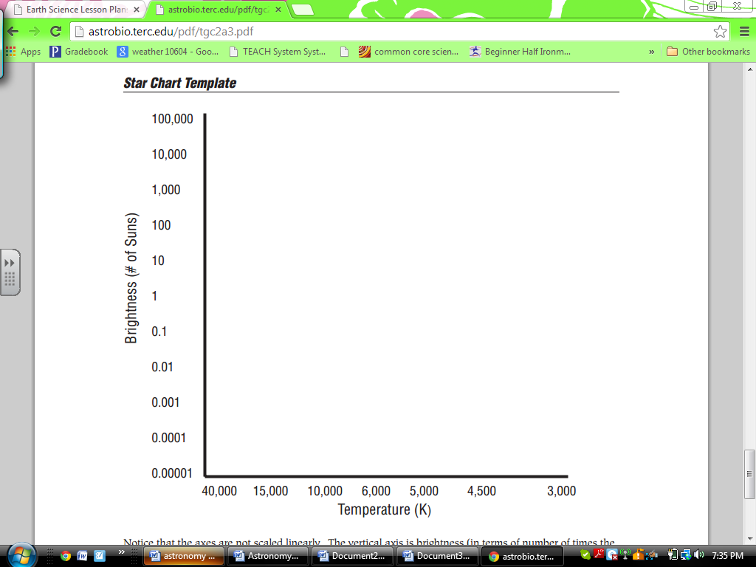

Discuss trends on the wall chart by considering the following questions:

• Describe the general trend between temperature and brightness.

As temperature ___________________________, brightness ___________________________.

This is a(n) _____________________________ relationship.

This is how the relationship looks when graphed:

• What is the color and brightness of the most abundant stars? The rarest stars?

Most abundant: color: _________________________ brightness: ___________________________

Most rare: color: _________________________ brightness: ___________________________

• What are the characteristics of the stars that do not conform to the graph’s trend?

• In terms of the graph’s trend, is our sun typical or exceptional?

• If you replaced the temperature scale on the graph’s x-axis with a color scale, which color would be closest to the graph’s origin and which would farthest away?

• In the stars that fit the general trend (these are often called main sequence stars), what relationship do you notice between color and expected lifetime?

As the color changes from blue to red, the expected lifetime ___________________________.

