Name: ___________________________________________ Date: _________________________
Lab Partners: _____________________________________ and ________________________________
LAB #______: MAKING A TOPOGRAPHIC MAP
Introduction: “You are here”, the sign at the intersection of the trail says. Maps help us find where we are and where we need to go, but topographic maps also give us other information. Features like trails, bodies of water and elevation can be found through the use of a topographic map.
Purpose: By the end of this lab you will be able to:
- Discuss general concepts of topography and topographic maps
- Identify key features of topographic maps
- Interpret topographic maps

Vocabulary: Match the definition with the word
________ contour interval a. a line of equal elevations
________ contour line b. the height above or below a fixed point (sea level)
________ elevation c. the difference in elevation between 2 side by side lines
________ gradient d. the measure of steepness of a feature
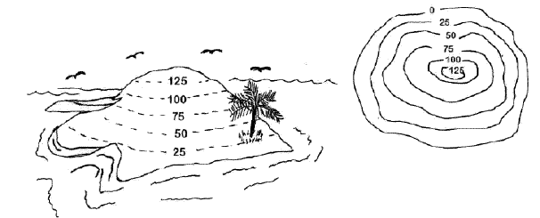
Warm-up: How are these 2 images related?

Materials: Check that you have the following
- 7 foam cutouts (4 black, 3 white)
- 1 wooden peg
Procedure:
- Layout the cutouts in order of smallest to biggest
- Position the so that the V shape is to the right
- Taking the biggest cutout and lay it flat on the desk, put the flat end of the peg through the left hole
- Place the next biggest cutout on top of the first by feeding the left hole through the peg
- Continue this process with the other 5 pieces
Data: Using your model for reference, draw and label the following features in the table.
FEATURE | CONTOUR SKETCH | DESCRIPTION
Stream Valley
Steep Slope
Gentle Slope
Draw the model that you just constructed:

Add the following to the sketch above:
- Put an X on the side that is the steepest
- Put an arrow showing the direction that the river would flow
- Draw a house on the place that you think you would have the best view

